The input for the file should be given in this format

When you execute calendar.py file in cmd you will view a prompt on your screen, similar to this image

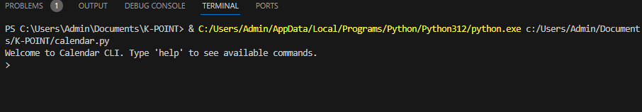

Type help command as asked on the screen, as you type help command you will get three options as shown in below image

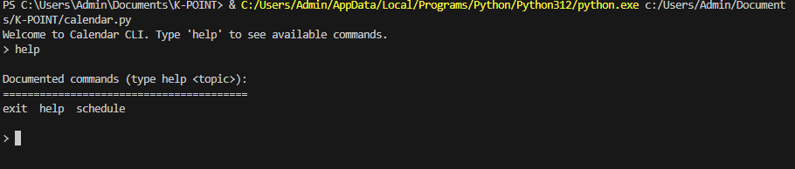

After this for scheduling the meeting type schedule command and provide the arguments , 5 arguments need to be provided which should be separated by space.

Name, Start Time, End Time, Room Id, Participants. The format in which you have to pass the time is

**2024-04-02T10:00:00**

I have provided an example and highlighted it.

